PRAS Accounts Payable Setup
Payables Lookup
Manual (R12)

Client:
Shared Service Center
Finance and Accounting Department

Author:
Creation Date: January 8, 2015
Last Updated: January 8, 2015
Control Number and Version are marked by a Word Bookmark so that they can be easily reproduced in the header and footer of documents. When you change either of these values, be careful not to accidentally delete the bookmark. You can make bookmarks visible by selecting Tools->Options…View and checking the Bookmarks option in the Show region.

- PROCEDURE DETAILS

2.1. Log in into Oracle Application 11i using your Username and Password
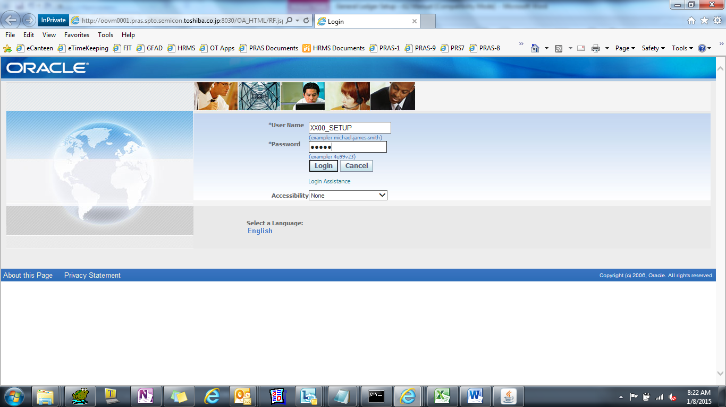

2.2. Select XXD4 TIP Payables Manager Responsibility
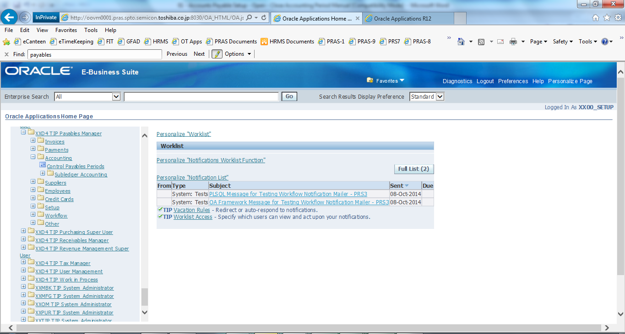

AP Payables Lookup

(N) Setup > Lookups > Payables
TYPE : SOURCE

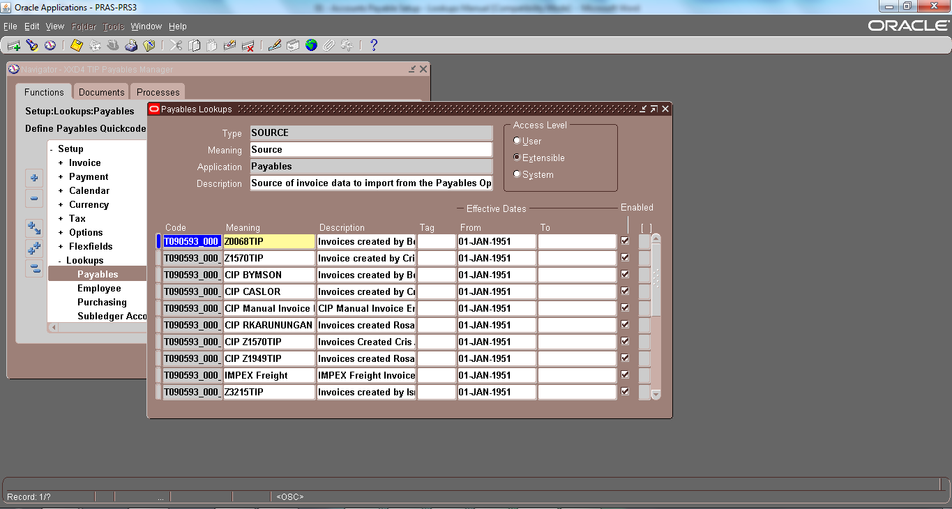
New AP-PIC must be registered first in AP Source in order to process invoices that requires the source to avoid error during processing.

Request SSC to register in GAIA first and provide us the GAIA Code equivalent.
Note : Source Type is used as validation during Transfer of AP invoices data.

REGISTERED AP SOURCES

Code | Lookup Code Meaning | Lookup Code Description
T090593_000_0006 | Z0068TIP | Invoices created by Beryl Ymson
T090593_000_0007 | Z1570TIP | Invoice created by Cris Aslor
T090593_000_0009 | CIP BYMSON | Invoices created by Beryl Ymson
T090593_000_0010 | CIP CASLOR | Invoices created by Cris Aslor
T090593_000_0012 | CIP Manual Invoice Entry | CIP Manual Invoice Entry
T090593_000_0013 | CIP RKARUNUNGAN | Invoices created Rosalie Karungan
T090593_000_0015 | CIP Z1570TIP | Invoices Created Cris Aslor2
T090593_000_0016 | CIP Z1949TIP | Invoices created Rosalie Karungan
T090593_000_0020 | IMPEX Freight | IMPEX Freight Invoices
T090593_000_0021 | Z3215TIP | Invoices created by Ismael Ponado
T090593_000_0023 | Z1462TIP | Invoice created by Jacelyn De Claro
T090593_000_0025 | Z3143TIP | Invoices created by Layzel Joyce Lira
T090593_000_0028 | Z0009TIP | Invoice created by Nenoca Oquialda
T090593_000_0029 | PRS | Payment Requisition System
T090593_000_0030 | Z1949TIP | Invoices created by Rosalie Karunungan
T090593_000_0032 | SSS CLAIM | SSS Reconciliation System to AP
T090593_000_0040 | MANUAL INVOICE ENTRY | LTI Manual Invoice
T090593_000_0041 | CIP Z3215TIP | Invoices created by Ismael Ponado
T090593_000_0042 | CANTEEN | Canteen Billing
T090593_000_0043 | Z5624TIP | Invoices created by Alvin Lorejas
T090593_000_0044 | Z5629TIP | Invoices created by Kem Paulo Torres
T090593_000_0045 | Z5671TIP | Invoices created by LLoydem Bederico
T090593_000_0046 | Z5642TIP | Invoices created by Rosiela Dollente
T090593_000_0047 | Z5679TIP | Invoices created by Reyniel Llenaresas
T090593_000_UPL | T090593_000_UPL | Data Upload

